Setting up your Demo Environment & Visual Studio Azure Subscription

# Introduction

In preparation for the Hackathon, you will need to have an environment setup to build. This document will provide you with links to the resources that can help along the way.

*Note: If you already have a demo environment set up, no need to create a new one for this hackathon.*

**It is imperative that you finish this work before you show up for the hackathon**. There is no time set aside during the hackathon to setup your demo environment.

This environment can be used for future customer demos or just to practice and learn.

# Setup Overview

The high-level process you will follow to get your demo ready is:

1. Create your M365 demo tenant.
2. Activate your Azure account.
3. Tips.

## Create your M365 demo tenant.

Leverage the [CDX demo tenant](https://cdx.transform.microsoft.com/) service to create your M365 demo tenant. Use your Microsoft account when logging in to the CDX site.

1. Go to “My Environments”.

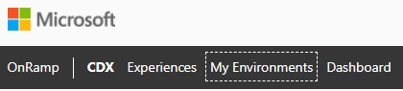

1. Select “Create Tenant” on the right.
2. We recommend setting up a Quick Tenant for 1 year using the **Microsoft 365 Enterprise Demo Content** package. (The provisioning of the tenant should take about one minute.)

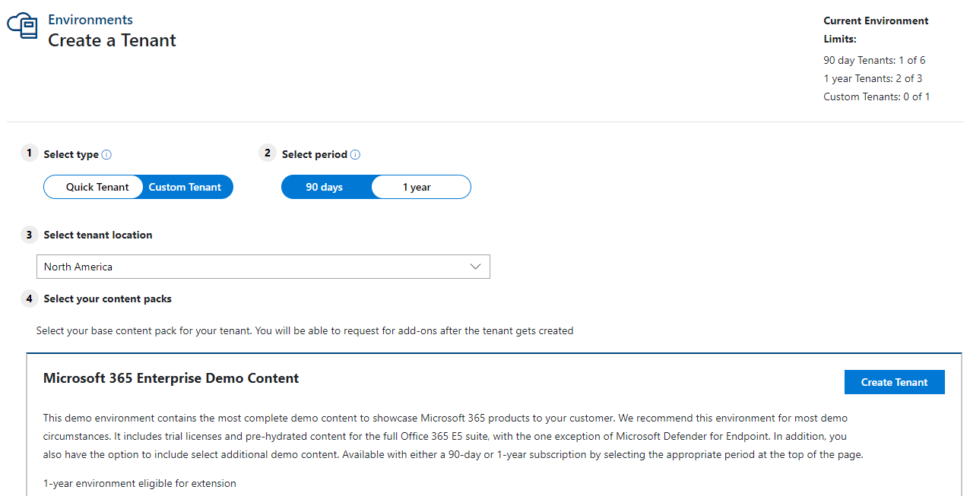

1. Make a note of your admin email and password.

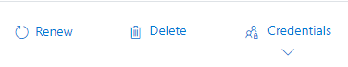

## Activate your Azure account using your MSA (Personal Microsoft Account).

**IMPORTANT:** If you have not activated your Azure credit through Visual Studio, complete the steps below.

Leverage the information [here](https://dev.azure.com/servicesdocs/DevOps/_wiki/wikis/Cloud%20Subscription%20in%20Microsoft%20Services/5414/Getting-Cloud-Subscription(s)-in-Microsoft-Services) to setup your Azure account. Ignore the reference to Microsoft Services in the title, as these resources are valid for all Microsoft Employees. For this purpose, use the [MSDN (Visual Studio Subscriptions) option](https://dev.azure.com/servicesdocs/DevOps/_wiki/wikis/Cloud%20Subscription%20in%20Microsoft%20Services/5419/Obtain-an-MSDN-subscription), which gives you access to your Azure credit through Visual Studio. Follow the instructions to set up your Azure account.

**IMPORTANT**: When asked to provide a personal account to link your subscription to, use your **MSA (Personal Microsoft Account).**

Once you have successfully activated your Azure account and can access the Azure portal logged in with your MSA, you are all set.

**Tips:**

* It is highly recommended you use [browser profiles](https://support.microsoft.com/en-us/office/sign-in-and-create-multiple-profiles-in-microsoft-edge-df94e622-2061-49ae-ad1d-6f0e43ce6435) when activating your Azure account, as you will be using your MSA.
* Use your Microsoft credentials to login to the Visual Studio site to activate your Azure credit but use your MSA to provision your Azure account.

## Tips:

1. **Pro-Tip for Microsoft Edge browser** – When you have obtained your M365 Demo Credentials, create a new profile in [Edge and save your credentials as a new profile](https://support.microsoft.com/en-us/office/sign-in-and-create-multiple-profiles-in-microsoft-edge-df94e622-2061-49ae-ad1d-6f0e43ce6435). You will want to do this with your M365 Demo Credentials as well as your MSA credentials.
2. Remember when accessing the Azure Portal ensure that you are using a browser profile with your MSA, not your Microsoft account.
3. If you did not copy your M365 Demo credentials, go to “My Environments” at the [CDX (Customer Digital Experiences) Portal.](https://cdx.transform.microsoft.com/)
4. Remember to login to Teams ([web version](https://teams.microsoft.com/)) using your M365 demo tenant credentials.

*Congrats! You’ve just setup a new Demo Tenant and Azure Subscription and are now ready for the Teams-as-a-Platform Internal Hackathon!*